Support the 43rd Idaho State Forestry Contest!
Thursday, May 14th
Farragut State Park, Scott Group Campsite
Athol, ID

Bonner Soil & Water Conservation District and Idaho Department of Lands are proud to co-sponsor the 43rd Idaho State Forestry Contest. This one-day, hands-on event provides Idaho’s youth with an invaluable opportunity to explore forestry and natural resource professions.

The Forestry Contest continues to grow. In 2025, over 225 students, 95 coaches/chaperones, and 150 volunteers participated. This success wouldn’t be possible without the generosity of our donors.
We sincerely thank you for your past contributions and ask for your continued support for the 2026 event. There are no entry fees for participants, and it costs approximately $11,500 annually to host the Contest, covering course supplies, equipment, rentals, and event-day expenses.

As a donor, your name will appear:

On the event banner displayed at the Contest,
In the Forestry Contest brochure provided to all participants and volunteers,
In newsletters and displays at multiple community events highlighting the Idaho State Forestry Contest, and
On the Bonner SWCD and Idaho Department of Lands websites.
Your support makes a lasting impact by helping students learn directly from natural resource professionals.

Career Fair
If you’re interested in participating in the Career Fair at the Contest by representing at a booth, contact John Gaddess at jgaddess@idl.idaho.gov to reserve your space.

Volunteering
If you or other members of your organization are interested in volunteering for a day or two at the Contest, please contact Hailey Frank, Volunteer Coordinator, at hfrank@idl.idaho.gov.

Thank you for investing in this important educational event!

Bonner Soil and Water Conservation District
130 McGhee Rd, Ste. 220, Sandpoint, ID 83864
208.255.9911 bonnerswcd@gmail.com
District website: http://bonnerswcd.org/forestry-contest

Donation Levels
  Champion Big Tree of Idaho - $2,500 +

Western White Pine - $1000 +  Western Red Cedar - $500 +

 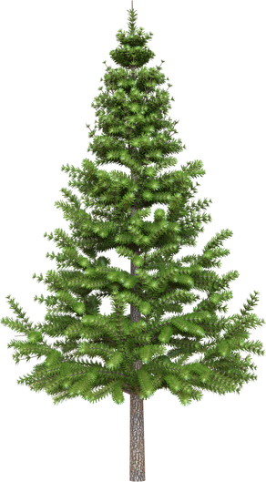 Douglas Fir - $300 +  Western Larch - $150 +  Aspen - up to $150
DONOR NAME AS YOU WOULD LIKE IT TO APPEAR:

How to Contribute: Select donation level above and write the donor name as you would like it to appear on the event signage and collateral.
Please make checks payable to “Bonner SWCD” with “Forestry Contest” on the memo line.
Mail this form and check to:
Bonner SWCD
130 McGhee Rd, Ste. 220
Sandpoint, ID 83864

If you would like to pay via credit card or need a copy of our W9, please visit: https://www.bonnerswcd.org/forestry-contest-donations.

To account for printing deadlines, donations received after April 17, 2026, may not be included in the printed materials but would be recognized in our final newsletter of the year as well as in the printed materials next year.

If you have questions about contest expenditures, please contact Bonner SWCD at bonnerswcd@gmail.com or 208.255.9911.

THANK YOU FOR YOUR SUPPORT OF THE IDAHO STATE FORESTRY CONTEST!
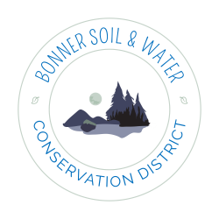
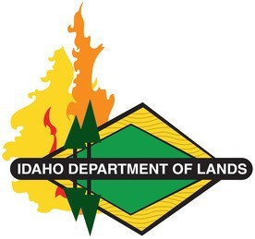
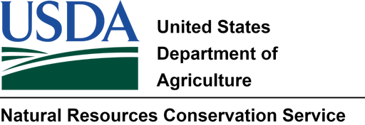
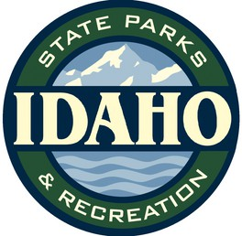
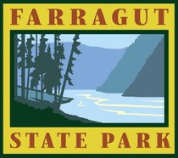

43RD ANNUAL IDAHO STATE FORESTRY CONTEST

More information can be found at: http://bonnerswcd.org/forestry-contest
bonnerswcd@gmail.com Ph: 208.255.9911

